**NAME : Ismail Wahyu Fadilah**

**NIM : 202010370311339**

**CLASS : RI D**

**Theme:**

SAM

# Overview

**Project Brief:**

This project is about designing the user interface (UI) and user experience (UX) for SAM applications, a software application aimed at helping users to mental health of a person

**Background:**

In the era of rapid technology that we face today, the discussion of electronic intelligence is a must. The presence of technology has changed the way we live, providing unlimited access to various needs and information. This phenomenon not only covers material aspects, but also affects people's mental health, especially among adults in Indonesia.

Amid the dynamics of modern life, many adults in this country are facing mental health challenges. In this context, health applications that can be accessed through electronic devices such as smartphones are an indispensable solution. To address mental health issues, such apps may teach breathing exercises, provide meditation guidance, and assist in scheduling meals regularly.

It is undeniable that mental health difficulties are often the result of social isolation and lack of emotional support. Therefore, involving technology in helping individuals who may not have friends or social support is a positive step. With the use of smartphones and extensive internet connectivity, mental health apps can provide accessible and reliable help.

Mental health illnesses can be caused by a variety of factors, such as lack of physical activity, low levels of mental health education, irregular eating habits, and lack of meditation practices. By detailing these issues, we can better understand the challenges faced by many adults today.

The importance of a holistic approach to mental health cannot be overstated. Therefore, this study will explore how the application of electronic intelligence can help address various aspects of mental health faced by Indonesians. By understanding more deeply this problem, it is hoped that effective and innovative solutions can be found to improve people's mental well-being.

**Research Success Criteria:**

|  |
| --- |
| * Use of Health Consultation * Helps make it easier for users to engage in Health Education * Use of Breathing Regulation &; Sound Health features |

**Deliverables:**

|  |  |
| --- | --- |
| • | Documentation UI/UX evaluation report |
| • | Suggesting design improvements involves writing actionable recommendations to improve the user interface, navigation, and visual elements with the goal of improving the overall user experience. |

# Hypothesis

**Assumptions:**

|  |  |
| --- | --- |
| • | UI/UX design enhancements will increase user engagement when using all SAM app features, as demonstrated by the increased frequency of sharing reviews and recommendations. |
| • | Improvements to UI/UX design will increase the level of user use of the app in the long run, which means users are likely to continue to use the app actively for a longer period of time. |

# Methods

**Qualitative Methods:**

|  |
| --- |
| Using in-depth interviews can provide a deeper understanding of a user's views and experience |

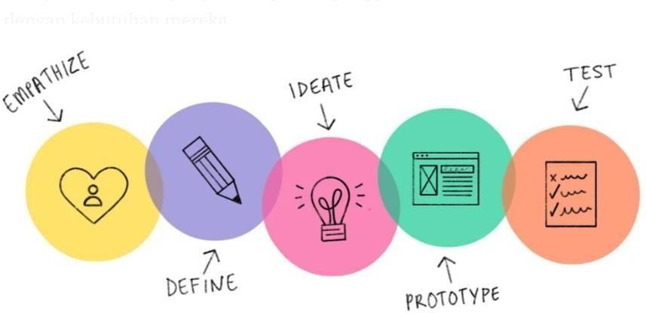

# Emphatize

This stage has been planned to deepen understanding the needs of users and guide me in making accurate decisions. In order to achieve this goal, I conduct interviews with users to gather the necessary information. In this way, I hope to dig deeper into the needs of users so as to design a suitable solution that suits and matches their needs.

User target :

1. People suffering from Mental Health
2. People in need of physical and spiritual health
3. People who need calm

# **User Research**

## Responden #1

**Participant Information:**

Nama: Linda

Age: 20 Years

Occupation: Student

**Warm-up Questions:**

1.Do you know what mental health is?

' Answer : yes I know

2. Do you need mental illness treatment with sound meditation? Answer: yes I need it

**Main Questions:**

1. Do you need treatment of diseases with respiratory methods? Answer: yes I need it to heal him
2. Is it important in the process of handling your mental health treatment using physical and spiritual fitness techniques Answer: yes it is very important to me
3. Are there any features you want to be in this SAM application? Answer: I need an educational tool about mental health

**Wrap-up:**

We greatly appreciate your time and contribution in this interview. The information you provide will be very useful in the development of UI / UX of our freight forwarding service application. If you have additional information or further questions, please let us know. If you have nothing else to say, we would like to thank you once again for your valuable participation in this research.

## Responden #2

**Participant Information:**

Name: Danis

Age: 19 Years Old

Occupation: Student

**Warm-up Questions:**

1.Do you know what mental health is?

` Jawaban : say kurang tau

2. Do you need mental illness treatment with sound meditation? Answer: yes I need it

**Main Questions:**

1. Do you need treatment of diseases with respiratory methods? Answer: yes I need it to heal him
2. Is it important in the process of handling your mental health treatment using physical and spiritual fitness techniques Answer: yes it is very important to me
3. Are there any features you want to be in this SAM application? Answer: I need body fitness features

**Wrap-up:**

We greatly appreciate your time and contribution in this interview. The information you provide will be very useful in the development of UI / UX of our freight forwarding service application. If you have additional information or further questions, please let us know. If you have nothing else to say, we would like to thank you once again for your valuable participation in this research.

## Responden #3

**Participant Information:**

Name: Fadil

Age: 23 Years Old

Occupation: Student

**Warm-up Questions:**

1.Do you know what mental health is?

' Answer: I understand

2. Do you need mental illness treatment with sound meditation? Answer: I don't really need it

**Main Questions:**

1. Do you need treatment of diseases with respiratory methods? Answer: yes I need it to heal him
2. Is it important in the process of handling your mental health treatment using physical and spiritual fitness techniques Answer: yes it is very important to me
3. Are there any features you want to be in this SAM application? Answer: I need the Meditation feature

**Wrap-up:**

We greatly appreciate your time and contribution in this interview. The information you provide will be very useful in the development of UI / UX of our freight forwarding service application. If you have additional information or further questions, please let us know. If you have nothing else to say, we would like to thank you once again for your valuable participation in this research.

## Responden #4

**Participant Information:**

Name: Abi

Age: 17 Years Old

Occupation: Student

**Warm-up Questions:**

1.Do you know what mental health is?

' Answer: I understand

2. Do you need mental illness treatment with sound meditation? Answer: I don't really need it

**Main Questions:**

1. Do you need treatment of diseases with respiratory methods? Answer: yes I need it to heal him
2. Is it important in the process of handling your mental health treatment using physical and spiritual fitness techniques Answer: yes it is very important to me
3. Are there any features you want to be in this SAM application? Answer: I need the breathing exercise feature

**Wrap-up:**

We greatly appreciate your time and contribution in this interview. The information you provide will be very useful in the development of UI / UX of our freight forwarding service application. If you have additional information or further questions, please let us know. If you have nothing else to say, we would like to thank you once again for your valuable participation in this research.

## Responden #5

**Participant Information:**

Name: Yoga

Age: 21 Years Old

Occupation: Student

**Warm-up Questions:**

1.Do you know what mental health is?

' Answer: I understand

2. Do you need mental illness treatment with sound meditation? Answer: I don't really need it

**Main Questions:**

1. Do you need treatment of diseases with respiratory methods? Answer: yes I need it to heal him
2. Is it important in the process of handling your mental health treatment using physical and spiritual fitness techniques Answer: yes it is very important to me
3. Are there any features you want to be in this SAM application? Answer: Maybe all the features described at the beginning are enough, it's just that I want the application to be lighter and easier to use

**Wrap-up:**

We greatly appreciate your time and contribution in this interview. The information you provide will be very useful in the development of UI / UX of our freight forwarding service application. If you have additional information or further questions, please let us know. If you have nothing else to say, we would like to thank you once again for your valuable participation in this research.

### Define

At this stage, we combine previously collected data to design solutions that can help users lead a healthy lifestyle. This step focuses on using information about user needs and preferences to ensure that the resulting solution is fit for purpose and effective in meeting their needs.

User Persona

### Ideate

In the initial step of designing solutions to overcome previously identified problems, a number of activities are carried out, including developing solution ideas, grouping similar ideas using the affinity diagram method, and setting priorities on the ideas generated.

Solution Idea

After generating solution ideas, I grouped them into one category, namely Explore new lifestyles

**EKSPLOR KESHATAN MENTAL**

Affinity Diagram

After grouping similar ideas using an affinity diagram, the next step is to prioritize them by creating a list based on their importance, which is referred to as idea prioritization. The goal is to focus on the most vital ideas and provide the greatest benefit to users. By prioritizing these ideas, I can use resources and time more efficiently to develop optimal solutions according to user needs.

#### Prototype

In this stage, I will create a simple application interface design to give a clear picture of how users will use the application. The goal is to ensure that the application design plan can be properly implemented as an interface that is easy for users to understand. Using wireframes, I can evaluate design ideas and determine improvements that need to be made before developing a more complete prototype version.

Prototype

After creating a wireframe to illustrate how the user will interact with the application, the next step is to create a user interface design (UI design) that features a realistic and user-friendly interface. At this stage, I'll combine design elements such as colors, typography, icons, and images to create an attractive and user-friendly look for users. The goal is to create an application interface that can be easily understood by users, enticing them to continue using the application. Through UI design, I can ensure that the app has a consistent and professional look and feel, and provides an optimal user experience.

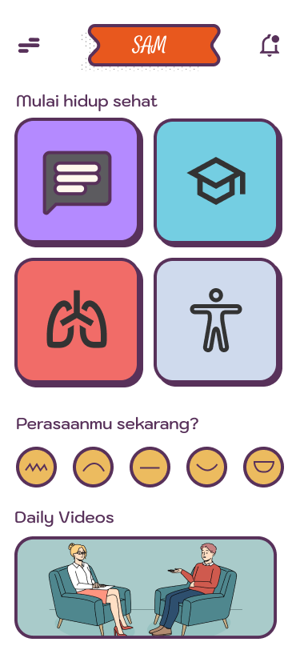 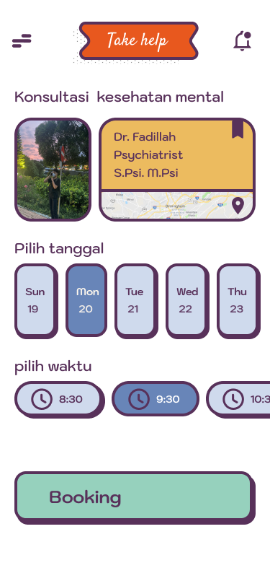

Home Mental health counseling page

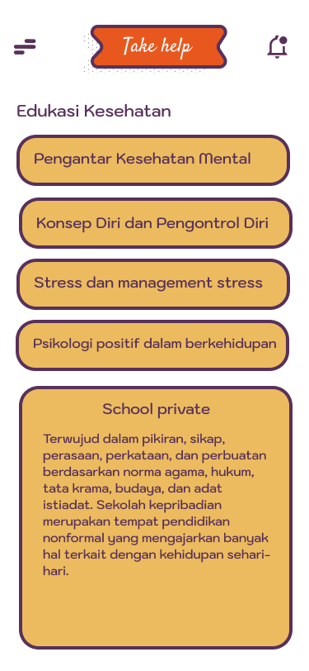 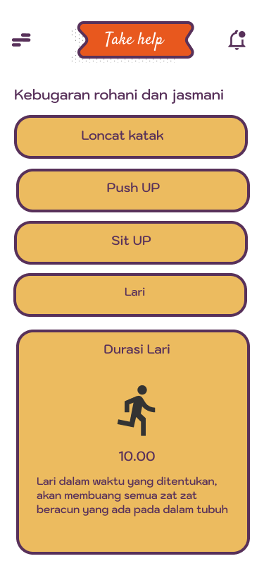

Education Page Mental health Fitness page Spiritual and physical fitness

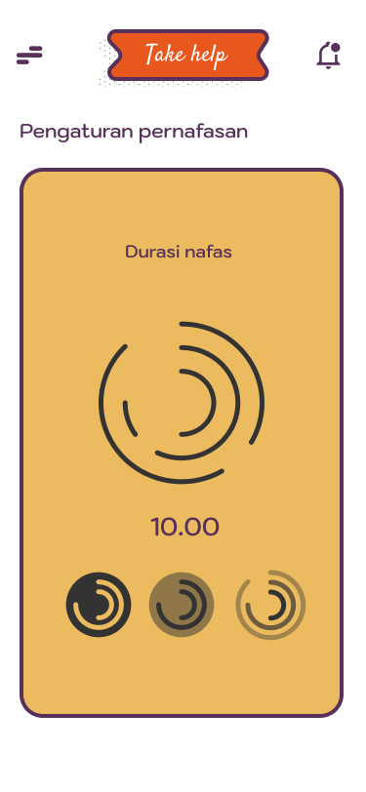

Breathing exercises page

UsabilityTesting

In the final stage, I used Maze.co website to test how users interact with the app service. The goal is to help the design team assess the extent to which the service is easy for users to use.

Link Maze : <https://t.maze.co/207894525>

Link Report : <https://app.maze.co/report/Project-5/3i5nhtlq1fcvq5/intro>

1. First Test Prototype

1. Second Test Prototype

1. Third Test Prototype

1. Fourth Test Prototype

